**Title: RFID Reader for Inventory and Element Tracking**

**Descriptive Overview:**

The RFID-based inventory and element tracking system is designed to streamline the process of managing and tracking items in warehouses, manufacturing plants, and laboratories. By using RFID technology, the system allows for real-time visibility of assets, reducing human error and optimizing inventory management. Each item is equipped with an RFID tag, which, when scanned by an RFID reader, updates the inventory database, ensuring efficient tracking and monitoring of items as they move through the supply chain.

**Hardware with Price:**

**1. RFID Reader (UHF or HF RFID Reader): Approx. $30 - $50**

This device reads the unique identifier (UID) from RFID tags and communicates it to a connected system for data logging.

**2. RFID Tags (UHF or HF Tags): Approx. $0.50 - $3 per tag**

Each item is tagged with a unique RFID tag, which can be a sticker, label, or embedded chip for tracking.

**3. Microcontroller (Arduino or ESP32): Approx. $25 - $30**

Acts as the processing unit, collecting data from the RFID reader and managing input/output for tracking.

**4. Real-Time Clock Module (RTC DS3231): Approx. $5**

Tracks the exact time when items are scanned and updates the inventory status with accurate timestamps.

**5. LCD Display (16x2 or 20x4): Approx. $10 - $15**

Provides real-time feedback, such as item ID and scan success or failure, to the user during inventory operations.

**6. Buzzer and LEDs: Approx. $5**

Auditory and visual indicators for successful or failed scans, helping users track inventory status quickly.

**7. Wi-Fi Module (Optional, ESP8266): Approx. $5 - $10**

Enables wireless data transfer to a central inventory management system or cloud-based platform for real-time tracking and analysis.

**8. Power Supply (5V Adapter or Battery): Approx. $5**

Supplies power to the system, ensuring consistent operation during tracking processes.

**Total Estimated Hardware Cost:**

- For a basic system: **$60 - $80**

- For an advanced system (with Wi-Fi, real-time tracking): **$80 - $120**

**Working Principle and Output:**

**1. System Setup:**

Each item in the inventory is tagged with a unique RFID tag. RFID readers are strategically placed at entry points, exit points, or specific stations where items are moved, scanned, or updated.

**2. Item Scanning:**

As items are moved within the facility, the RFID reader scans the tag, capturing the unique ID. This data is sent to the microcontroller for processing.

**3. Data Processing:**

The microcontroller matches the scanned RFID tag to a database of items, logs the scan with a timestamp from the RTC, and updates the inventory record to reflect the current status and location.

**4. Feedback:**

The system provides immediate feedback to the user via the LCD display, showing whether the scan was successful, the item ID, and its updated inventory status. LEDs or a buzzer provide additional visual and auditory confirmation.

**5. Data Storage and Reporting:**

Inventory data can be stored locally (SD card or EEPROM) or uploaded to a cloud-based or central database via Wi-Fi, where administrators can access detailed reports and real-time data on stock levels, item locations, and movement history.

**Output:**

**For Admins:** Detailed logs of inventory movements, including timestamps, item IDs, and location updates, ensuring accurate tracking of stock and elements.

**For Users:** Real-time confirmation of item status through display, auditory signals, and system indicators.

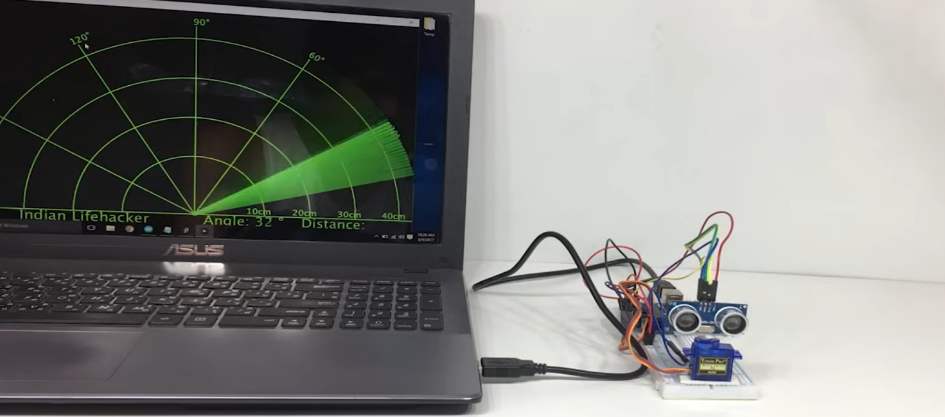

**Figure 1. RFID Reader for Inventory and Element Tracking**

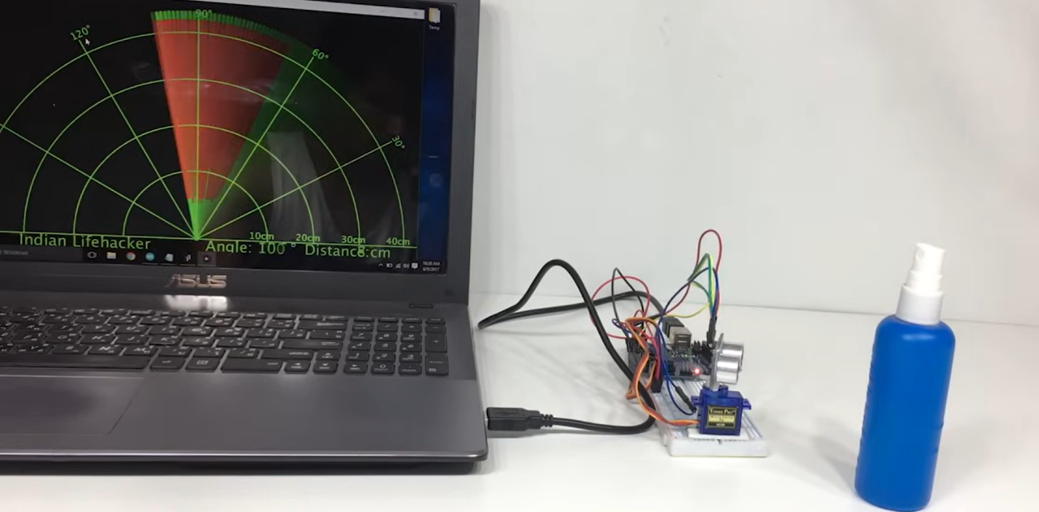

**Figure 2. RFID Reader for Inventory and Element Tracking Product design**

**Benefits with Examples:**

**1. Improved Accuracy:**

- Example: In a manufacturing facility, RFID ensures precise tracking of components from the warehouse to the production floor, reducing lost items and misplaced stock.

**2. Real-Time Inventory Management:**

**- Example:** A warehouse manager can monitor stock levels in real time, automatically receiving alerts when items are scanned in or out of storage, improving decision-making for restocking.

**3. Efficient Workflow:**

**- Example:** Instead of manually logging item movements, employees can quickly scan RFID tags, reducing the time spent on tracking and minimizing errors in record-keeping.

**4. Scalability:**

**- Example:** The system can be expanded by adding more RFID readers to cover additional areas or warehouses, allowing for seamless scaling as the business grows.

**5. Integration with Other Systems:**

**- Example:** The RFID system can integrate with inventory management or enterprise resource planning (ERP) systems, automating stock updates and simplifying order processing.

**6. Secure and Tamper-Resistant:**

**- Example:** Each item has a unique RFID tag, making it difficult to tamper with inventory records, ensuring higher security and integrity of data.

**Conclusion:**

The RFID-based inventory and element tracking system provides a reliable, scalable, and efficient solution for managing and monitoring stock levels and tracking the movement of items in real time. This system is ideal for warehouses, manufacturing plants, and businesses where accurate inventory management is critical, offering benefits such as enhanced accuracy, improved workflow, and seamless integration with existing systems.

K. Umesh Chandra (192210308)

C. Janardhan Reddy (192211819) Dr. Shri Vindhya A